**HINDUSTHAN COLLEGE OF ENGINEERING AND TECHNOLOGY**

**(AUTONOMOUS)**

|  |  |
| --- | --- |
| Date | 6st November 2022 |
| Team ID | PNT2022TMID34140 |
| Project Name | IOT Gas Leakage Monitoring and Alerting System. |
| Maximum Marks | 4 Marks |

**TECHNICAL ARCHITECTURE:**

The Deliverable shall include the architectural diagram as below and the information as per the table1 & table 2.

**Example**: Gas Leakage Monitoring & Alerting System for Industries.

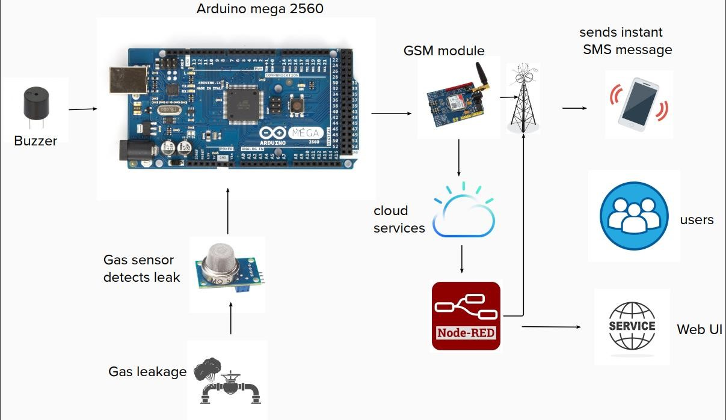

**Table-1: Components & Technologies:**

|  |  |  |  |
| --- | --- | --- | --- |
| **S.No** | **Component** | **Description** | **Technology** |
| 1. | Arduino MEGA | The Arduino Mega 2560 is a microcontroller board based on the ATmega2560 (datasheet). It has 54 digital input/output pins (of which 14 can be used as PWM outputs), 16 analog inputs, 4 UARTs (hardware serial ports), a 16 MHz crystal oscillator, a USB connection, a power jack, an ICSP header, and a reset button. | It consists of two memories such as program memory and data memory. Wherein the data is stored in data memory and the code is stored in the flash program memory. |
| 2. | Gas Sensors | The Grove - Gas Sensor (MQ5) module is useful for gas leakage detection and for monitoring the air quality. | A gas sensor is a device which detects the presence or concentration of gases in the atmosphere. Based on the concentration of the gas the sensor produces a corresponding potential difference by changing the resistance of the material inside the sensor, which can be measured as output  voltage. |
| 3. | Web App | An application that is used to the see the gas level, GPS location and see the total overview of the system. | An app is a type of software that allows you to perform specific tasks. Applications for desktop or laptop computers are sometimes called desktop applications, while those for mobile devices are called mobile apps. When you open an application, it runs inside the operating system until you close it. |
| 4. | IBM cloud | The IBM Cloud platform combines platform as a service (PaaS) with infrastructure as a service (IaaS) to provide an integrated experience. The platform scales and supports both small development teams and organizations, and large enterprise businesses. | Platform as a Service (PaaS) is a cloud computing solution that provides developers with an easy-to-use platform to create their own software, web applications, or other programming projects. |
| 5. | Mobile Phone | Whenever the excess gas is detected, SMS will be sent to a particular phone number. Smoke and gas leakage detectors are very useful in detecting smoke or fire in buildings, and so are the important safety parameters in order to prevent disasters. | The system alerts notifications to the end-user who responds accordingly with the help of connected devices such as a smartphone on the go. |
| 6. | GSM and Fast SMS | GSM (Global System for Mobile communication) is a digital mobile network that is widely used by mobile phone users in Europe and other parts of the world. Fast2SMS provide API for bulk SMS, which ensures security and it is a very reliable source of sending data. | When you send an SMS message, the message gets transmitted from the sending device to the nearest cell tower. That cell tower passes the message to an SMS centre (SMSC). Then the SMSC forwards the SMS message to a cell tower near the receiving device. |
| 7. | Buzzer | A buzzer is a loud noise-making or an audio signalling device, which may be mechanical, electromechanical or piezoelectric. | Typical uses of buzzers include alarm devices, timers, train and confirmation of user input such as a mouse click or keystroke. |

**Table-2: Application Characteristics:**

|  |  |  |  |
| --- | --- | --- | --- |
| **S.No** | **Characteristics** | **Description** | **Technology** |
| 1. | Open-Source Frameworks | MQ5 gas sensor, Wi-Fi, Arduino processor chips. | Internet of Things. |
| 2. | Security Implementations | MQ5 gas sensor, alerting device which consists of Buzzer. | Internet of Things. |
| 3. | Scalable Architecture | Detecting room temperature, if the temperature is above the specified temperature, it will alert workers. | Python. |
| 4. | Availability | Use of Wi-Fi IP address. | Internet of Things. |
| 5. | Performance | Performance is efficient. | Internet of Things. |